

# **MANDALAY CAPABILITIES STATEMENT**

Why choose to partner with Mandalay?



## What sets Mandalay apart?

Through the power of cloud computing, Mandalay offers a unique collection of solutions that manage data, business intelligence and data synchronisation. Whether you have single or multiple installations, Mandalay creates an environment that centralises your applications and data. Providing improved accessibility, functionality, reliability and reporting capability.

Looking beyond the weighbridge, Mandalay can integrate with multiple data points that are already being captured across your waste ecosystem.

Beyond the Weighbridge

Mandalay started business as a weighbridge software company and is now the leading provider of software and data management systems for the resource recovery industry in Australia.

Mandalay is committed to a world without waste – where the materials generated by the community move from a cost centre to a revenue generator and become a resource.

The right data is critical to the success of an organisation and so too are the processes that utilise and audit that data. Mandalay helps councils and communities to create circular economies. The following are what set Mandalay apart:

Leaders in data collection, information control and management.

**Leadership within the industry**

**Product roadmap**

**Usability**



**A local team means local support**



**Investment in technology development**



**



**A local team means local support**

Based in Australia and dealing with more than 450 operational sites across Australia and New Zealand means that we have local knowledge and understanding of the industry.

Mandalay employs five experienced waste industry experts who can assist with strategic, operational and financial decisions either through our fantastic service desk or as consultants in an advisory role on a project basis.

Our team of 35 includes:

**A dedicated support team** - implementing new projects and supporting customers with existing installations.

**A development team** - continually working to improve and expand on existing product, plus stay up to date with regulatory requirements.

**A project management team** - managing and guiding projects ensuring projects run smoothly.

**A sales and customer success team** - recommending, educating and ensuring the best outcomes for all.

**A marketing and finance team** - working hard behind the scenes.

**Investment in technology development**

Through listening to our customers’ needs, Mandalay’s Australian based development team continues to invest in our technology, to the tune of $1.5M per year. We have been doing this for the past 10 years.

This ongoing commitment has seen the evolution from weighbridge to data management and insights.



**Leadership within the industry**

With over 20 years within the waste industry Mandalay has built a thorough understanding of industry best practice and how Councils setup and manage operational flows to support regulatory compliance. Working with Councils, Mandalay provides ongoing and proactive support across the industry.

We proactively save Councils thousands of dollars in overpaid levy.

By ensuring compliance, Councils have avoided fines and penalties.

Our team actively contributes to the industry through presentations, workshops and speaking engagements and education across the sector around best practice and improving the operations of your facility.



## Why Mandalay?





## Why Mandalay? (cont.)

**

**Waste Facilities**

Capturing transactional information across a number of waste facility types, including Landfill Facilities, Material Recovery Facilities, Transfer Stations and Organic Recycling Facilities.

**Waste Management**

Managing data captured from single sites and unmanned sites, or aggregating data captured across multiple sites.

Providing fraud management, auditable reports, dashboards and API integration with other systems.

**Enablers**

Through continued industry wide and tailored customer training, data structure design, risk management, consulting and ongoing support Mandalay is here to ensure that you are achieving the best outcomes from your facility and data.

**Regulatory**

Software tools and reporting that comply with current legislative and regulatory requirements across each state of Australia (e.g. waste levy, chain of responsibility).



## What are the solutions that Mandalay offers?

**Usability**

Mandalay provides the ability to integrate with existing systems (i.e. finance systems) and aggregate multiple locations and waste management facility types to create a holistic view of waste management within your region.



**Product roadmap**

Researching and investigating global trends. Identifying what is relevant to the Australian market and driving product development beyond the weighbridge.



Mandalay and our specialised software tools offer solutions across four key areas:

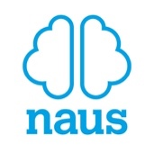

Mandalay CS Facilities Operating System

Mandalay Consulting



Waste Pathways

naus Intelligence Platform

What is Mandalay’s Product and Service Offering?

**Operational Audit & Strategy**

**Education & Training**

**Reporting & Compliance**

**Operational Performance**

**Audit & Analysis**

The full reporting, forecasting and management capabilities of Mandalay CS are realised through integration with the naus Intelligence Platform.

A new product offering in testing and development that will provide the ability to track waste data from waste source to waste fate. Taking existing C&I and C&D data and integrating MSW data to create a more holistic view of waste management within a region.

Current offerings include **Waste Vouchers** (Residents and Community Groups) and detailed **Waste Mapping** based on voucher use.

The **naus Intelligence Platform** is a cloud-based platform that centralises site data and provides the benefit of role-based user access, multi-directional data synchronisation, data backup and disaster recovery.

The **naus Insights** product will unlock and access the full power of data captured across your waste ecosystem through customisable dashboards to monitor, interpret and forecast.

The **Mandalay CS Facilities Operating System** is a Point of Sale (POS) system that captures and processes vehicle movements in and out of sites, while delivering critical functions like payment processing, hardware interfaces, and data capture. Modules include:

**EFTPOS**

**Image Capture**

**License Plate Recognition (LPR)**

**Financial Extracts**

**Voucher Management**

Mandalay provides a specialist offering in **Waste Industry Consulting**, focused on operational efficiencies, technology and data.

Services include:



## Mandalay’s Product Offering

**99% Uptime**

All services provided by Mandalay are backed by a 99% up time guarantee.

Planned service upgrades will be notified in advance and will take place outside of normal business hours.



**60min Response Time**

All service requests received by the Mandalay support team will be responded to within 60 minutes. Incidents are classified according to Mandalay’s Service Level Agreement (SLA) and resolved within the specified period.



Standard support hours are 8:00am to 5:00pm AEST Monday to Friday. However, Mandalay’s team is available for support 24 hours per day, 365 days per year with non-critical incidents charged at Mandalay’s standard after hours rates.

Project kick-off

**INITIATE**

Team introductions.

Project setup.

Hardware procurement.

Project planning

**ANALYSE**

Resources assigned and scheduled.

Detailed project schedule created.

IT checklist walkthrough.

Project execution

**EXECUTE**

Technical activities:

* PC Builds
* Business process mapping
* Integrations
* Hardware audits
* Migration activities
* Training
* UAT

Project status reports & meetings.

Cutover & Go Live Support.

Project complete

**CLOSE**

Project acceptance.

Post implementation review.

Handover to Mandalay support team.



**Service Levels**

A copy of Mandalay’s Service Level Agreement (SLA) can be provided. Please get in touch.

**Project Methodology**

What can you expect from Mandalay’s Project & Service Delivery?



## Project & Service Delivery

**Brendon Horswell** / Head of Support

Brendon has extensive experience in the waste and resource recovery sector spanning NSW, ACT and Queensland. A passionate leader with a strong focus on safety, accountability and operational efficiency, Brendon challenges his teams to ensure decisions are made in everyone’s best interest.

[www.linkedin.com/in/brendon-horswell-9930b49a](http://www.linkedin.com/in/brendon-horswell-9930b49a)

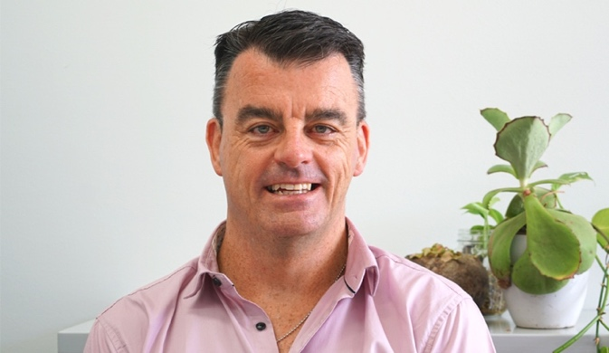

**Allard Bernhofen** / Business Development

Allard is a high performing business development executive with extensive experience in the Waste Industry. Allar​d has successfully created sales strategies that have led to positive sales growth and strategic expansion for organisations. He has focused his efforts around maintaining relationships that continue to increase resource recovery activity in both the public and private sectors within Australia.

[www.linkedin.com/in/allardbernhofen](http://www.linkedin.com/in/allardbernhofen)



**Rosemary Black** / Head of Customer

Rosemary’s areas of expertise include strategic business development, management and operations; performance management; sales and marketing; client and stakeholder engagement; financial and administrative governance including management of special projects. Rosemary has extensive experience across corporate and government sales often drawing upon relationship building techniques.

[www.likedin.com/in/rosemary-black](http://www.likedin.com/in/rosemary-black)

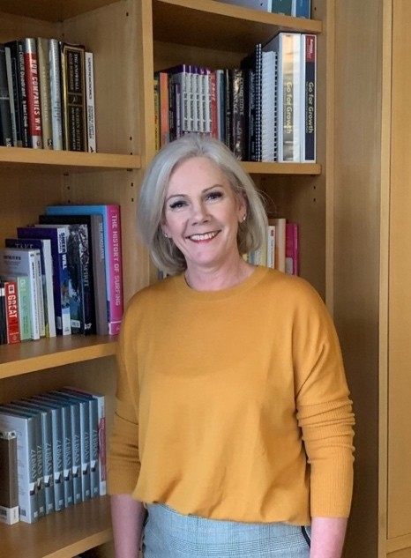

**Rex Heathwood** / Head of Product

Rex has a strong commercial background combined with a highly diverse exposure across a broad range of industries and roles, so he is well equipped to ensure the best ‘fit’ applications are applied and executed. Rex currently oversees Product Management, Development and Support across cloud, Software as a Service (SaaS) and desktop platforms.

[www.linkedin.com/in/rex-heathwood](http://www.linkedin.com/in/rex-heathwood)

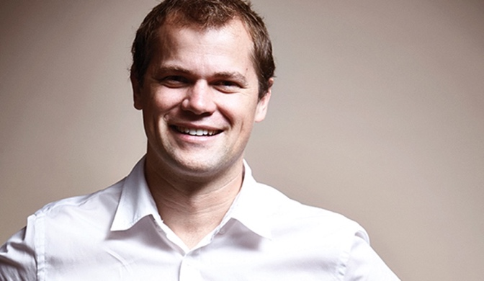

**Simon Kalinowski** / CEO

Simon is considered an emerging thought leader in the waste industry, particularly in the role data plays in leading the industry to meet the challenges faced in today's world and is a regular contributor to legislative reform discussions within the Australian waste industry. Simon is particularly passionate about leading meaningful change and the role industry professionals have in delivering an essential service.

[www.linkedin.com/in/simonkalinowski](http://www.linkedin.com/in/simonkalinowski)



## Key Team Members



## Key Team Members

**

**Darren North** / Consultant

Darren brings over 20 years' waste management and resource recovery experience in both the public and private sectors within Australia and the UK. He has extensive experience spanning both traditional and contemporary processing, disposal, recycling and recovery practises including many areas of sustainability, environment, behaviour change, and both single and multi-facility operations and management.

www.linkedin.com/in/darrenknorth/

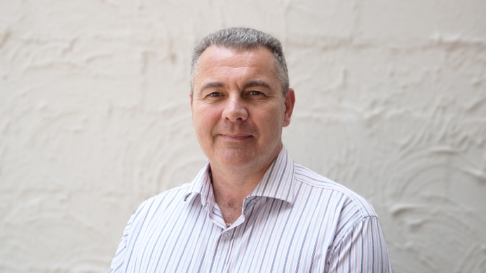

A collection of solutions to integrate data being captured across your waste ecosystem and transformed into usable information.

This is the future of waste.

The Weighbridge and Beyond

**Lacey Webb** / Senior Consultant

Lacey is a CPA qualified former CFO and industry experienced Waste Strategist & Consultant, specialising in Risk, Regulation and Compliance. Lacey is passionate about driving organisations to improve profitability and efficiency and her broad ranging financial, technical and operational experience allows her to lead change management across all levels of an organisation with ease.

[www.linkedin.com/in/lacey-webb/](http://www.linkedin.com/in/lacey-webb/)

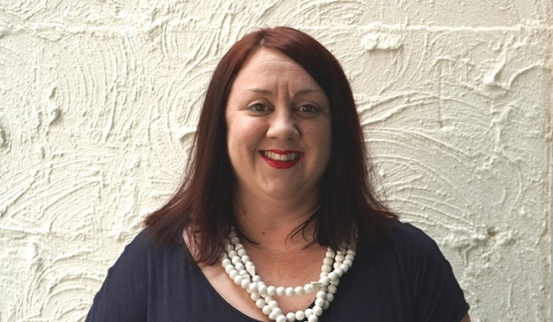

## Key Team Members

Get in Touch

Talk to us today about migrating to the   
**naus Intelligence Platform**

07 3010 7900  
[sales@mandalaytech.com](mailto:sales@mandalaytech.com)